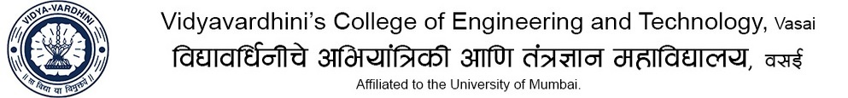

Department of Mechanical Engineering
Sub: Heat Transfer TE B Div A.Y : 2019-20
Assignment no 01

CO1: Identify the three modes of heat transfer (conduction, convection and radiation)

- Discuss modes of heat transfer
- Differentiate between free and forced convection.

- Compare electrical analogy with thermal resistance of conduction

- Difference between heat transfer and Thermodynamics

