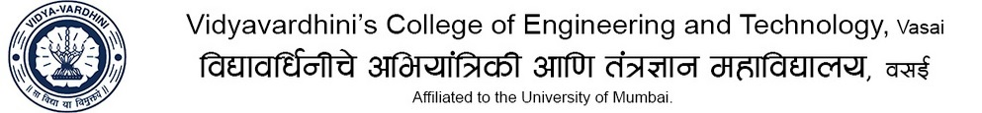

Department of Mechanical Engineering
Sub: Heat Transfer TE B Div A.Y : 2019-20
Assignment no 02

CO2: Illustrate basic modes of heat transfer

- A rectangular slab (k = 10 W/mK) of thickness 15 cm and inside temperature of 400°C is insulated by a materials of thickness 10 cm (K = 30 W/mK). The ambient air is at 28°C and the outside convective heat transfer coefficient is 15 W/m²K. Determine the steady state heat transfer per unit surface area and the temperature of outside surface of the slab and the insulation.

- A 1m long Nichrome wire dissipates a power of 10 kW to surrounding fluid at 80°C. Find the diameter of the wire if the maximum operating temperature of wire is 1000°C. Take, h = 1000 W/m²K and k for Nichrome as 60 W/mK.

- Write note on critical radius of Insulation.

