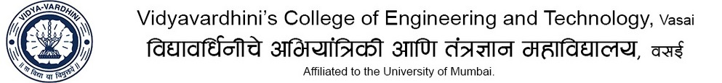_____________________________________________________________________________
Department of Mechanical Engineering

Class: TE (A&B) | Industrial Automation  Term Test 1 Syllabus | A:Y : 2019-20

CO1: Demonstrate basics of industrial automation (Apply)
CO3: Design electro-pneumatic, pneumatic and hydraulic circuits. (Create)
CO4: Selection of sensors and actuators. (Evaluate)

MODULE 1  (CO1) | Introduction to Automation: Definition and fundamentals of automation, reasons for Automating, basic elements of an automated system: Power, Program and control system Advanced automation functions: safety, maintenance & repair diagnosis, error detection and recovery Levels of automation. Automation principles and strategies: USA principle, ten strategies of automation and production system, automation migration strategy
MODULE 3  (CO3) | Hydraulic and pneumatic devices-Different types of valves, Actuators and auxiliary elements in Pneumatics & hydraulics, their applications and use of their ISO symbols Synthesis and design of circuits (up to 3 cylinders)–pneumatic, electro pneumatics and hydraulics Design of Electro-Pneumatic Circuits using single solenoid and double solenoid valves; with and without grouping
MODULE 4  (CO4) | Sensors & Actuators Sensors: Selection of sensors ( Displacement, temperature, acceleration, force /pressure) based on static and dynamic characteristics Interfacing: Concept of interfacing, bit accuracy and sampling speed, amplifying electronics, and microcontroller Actuators: Principle and selection of mechano-electrical actuators (1) DC motors (2) Stepper Motors (3) Solenoid Actuators (4) Servo Motors (5) BLDC

