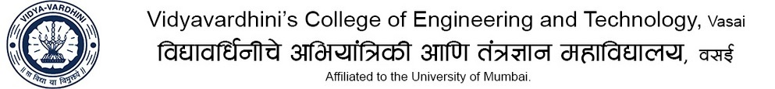_____________________________________________________________________________
Department of Mechanical Engineering

Class: TE (A&B) | Industrial Automation  Term Test II Syllabus | A:Y : 2019-20

CO2: Relate mechanization and automation. (Analyze)
CO5: Execute program in PLC for process industry (Apply)
CO6: Demonstrate basic working of robots. (Apply)

MODULE 2  (CO2) | Mechanization and automation, product cycle, hard Vs flexible automation, Capital- intensive Vs low cost automation Types of systems-mechanical, electrical, hydraulic, pneumatic and hybrid systems Automation using CAMS, Geneva mechanisms, gears etc. Assembly line Automation: automated assembly systems, transfer systems, vibratory bowl feeders, non-vibratory feeders, part orienting, feed track, part placing & part escapement systems Introduction to Material storage/ handling and transport systems, and its automation using AS/RS, AGVS and conveyors etc.
MODULE 5  (CO5) | Process industries versus discrete manufacturing industries, Continuous verses discrete control, Computer process control, Forms of computer process control Discrete control using PLC- discrete process control, Programmable logic controller, its architecture, ladder digs, Ladder Logic Programming for different types of logic gates, Latching, Timers, Counter, Practical Examples of Ladder Programming
MODULE 6  (CO6) | Introduction to robots, Types, Classifications, Selection of robots, Robot Degrees of freedom, Robot configuration, Accuracy and repeatability, Specification of a robot, Robot feedback controls: Point to point control and Continuous path control, Control system for robot joint, Adaptive control, Drives and transmission systems, End effectors, Industrial robot applications of robots

